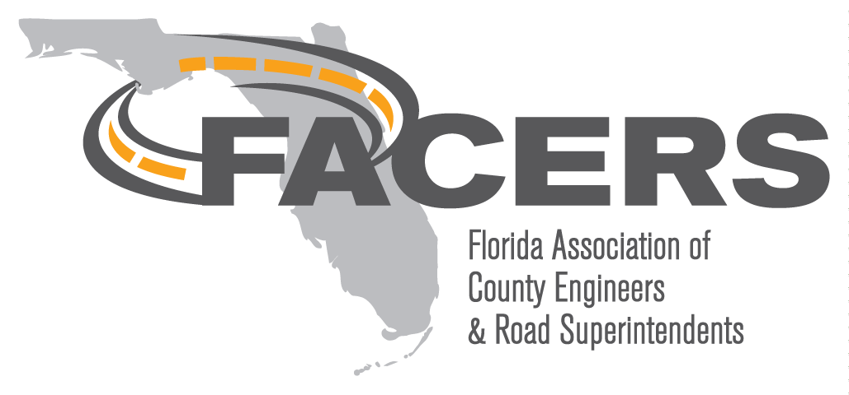
AGENDA
Board of Directors Meeting
Webex and Marion County, FL
February 5, 2021
10:00 am

- Call to Order, Tracy Straub, President Called to order at 10:06 - Meeting held via Webex hosted by Marion County
Members/guests present online were:
Judy Clarke, Tracy Straub, Ben Bartlett. Bob McKee, Kiryanna Stanley, Scott Herring, Shane Parker, Karen Sapp, John Goodnight, George Gadiel, Neil Shinkre, Brian Singleton, Chance Powell, Fred Schneider, David Ricks, Clinton “Gator” Howerton.

- Officer Reports:
  - Secretary’s Minutes, Gator Howerton: Minutes from December 3rd, 2020 meeting were distributed on Dec 21, 2020 via email. Motion made to accept by Shane, seconded by George. Motion passed.
  - Treasurer’s Report, George Gadiel: Report was emailed 2-5-21 and discussed. Membership goal was short. Sponsorships helped offset costs. Memberships are due for renewal. Motion made to accept by Neal, seconded by Scott. Motion passed
  - Vice President’s Report, Benjamin Bartlett:
    - Any wrap-up from Legislative Conference, December 2-4, 2020, Duval County? Will check to see if presentations are on website. With sponsorships, we were able to cover costs of conference.
    - Early prep for Annual Conference, June 30 – July 2, 2021, Orange County. Looking for options for presentations. Hoping for in person conference. Suggestion made to plan for virtual option at conferences. FAC looking to plan a hybrid conference. Will start checking on camera options.

- New Business:
  - Legislative Update, FAC: Bob McKee reported several bills presented and several presentations made in State Legislature. SB 138 and SB 140 are key, deals with electric vehicles; SB138 deals with charging, and SB140 deal with registrations. Bob will be working to put together some info on impacts to fuel tax revenues. Senate Bills 750 and 337 deal with impact fees and restrict growth of fees. Statewide, transportation revenues did take dip during pandemic but seem to be recovering. Concerns for diminished activity during spring.
March Conference (March 17th) will discuss items in process and provide information about hot topics and revenue estimates. Bob can be contacted at bmckee@fl-counties.com
  - Email Communications: - John G. to continue efforts to put together an email program. Requested to set up a “FACERS.net” specific domain.
  - Potential updates to FACERS Constitution, Brian Singleton and John Goodknight: Discussion on election of NACE officer, only 2 qualify for position currently (George W. and Ramon). Consensus was that elections for this position are not necessary at this time. Discussion was had to change the meeting dates to be in conjunction with FAC rather than at same time to ease coordination efforts. Consensus was in favor of making this change. John G. and Brian S. to work on a redline.

- Committee Reports and Updates:
  - Membership, George Gadiel: Renewals are due. Please renew if have not already done so. Reminders will be sent end of Feb or soon thereafter.
  - FACERS Budget, Ramon Gavarrete: Ramon was not present, Tracy shared there were no changes to budget from adopted 2020 budget.
  - FAC, Karen Sapp and/or Milan Clayton: started discussing annual conference. Sponsorships will be needed. Milan will continue to work on website.
  - NACE, Scott Herring:
    - Dues: best way to renew or add will be to pay via phone. Call them to do so.
    - Urban/Rural/Project Manager of the year: currently accepting nominations for these categories. Must be a NACE member. Deadline is March 5th. Application form is on the website www.countyengineers.org . Shane made motion to nominate Scott for this, Gator seconded it. Scott will provide information for the application.
    - PDH – NACE looking to add certification to provide PDH for presentations.
  - Legislative, John Goodknight:
    - Introducing Eddy Labrador, Sr Legislative Counsel with FAC
Email: elabrador@fl-counties.com; Cell: (954) 826-1155

  - Awards, Gator Howerton transition to Judy Clarke (new committee: Judy Clarke as Chair, David Ricks, Shane Parker, Margaret Smith): Will follow up and see if any other applications. Will follow up and strengthen the one received.
  - Scholarships, Steve Ferrell: Tracy reported – nothing new to report
  - Green Book, Shane Parker: no updates since last meeting.
  - LAP Community of Practice, John Goodknight: minutes emailed to directors. FDOT starting to do some pilot pushbutton contracts that may be helpful. If you have any potential projects, get with your district to discuss options. Status report on the roadway lighting maintenance agreement was also in the email. Emergency relief webinar being planned, check minutes for information (Feb 23rd).
  - LTAP, Pei-Sung Lin, CUTR: Kiryanna updated LTAP has trained over 24,000 people. 80% from Florida. Traffic signal timing 101 and 201 are examples. CEI certificate programs are available. www.floridaltap.org
  - T-Squared, Nithin Agarwal: not present, stay tuned for updates
  - Website, John Goodknight: Milan working to do website updates. More to come. Members encouraged to look at it and provide feedback and suggestions for updates.
  - Newsletter, Amy Blaida: Not present. Email of updates were sent out previous. $12,250 raised from sponsorships from last conference.

- Open Forum:
-Amy sent email from FAC asking if FACERS would be interested in attending a workshop for FAC June meeting. Consensus is that the group is interested. Ramon, Scott, John G. and Tracy to work on with Craigin of FAC.
-Neal will be transitioning to a new job, Asst. director of Utility Dept. St. Johns County.
-Discussion on budgets/gas taxes impacts.
-Discussion on PDH’s for attending FACERS directors meetings.
-Tracy offered that she looked into the ADA building code requirements for PE.

- Next meeting: 10am, Friday, March 26, 2021 via Webex and tentatively in person at the Marion County Office of the County Engineer, 412 SE 25th Ave, Ocala, FL 34471.

- Adjournment: Meeting adjourned at 11:34

